TITLE: SIGN LANGUAGE TRANSLATION MODEL

TEAM NAME : SKCODER

MEMBER 1 : SANJAI KUMAR R

COLLEGE: PANIMALAR ENGINEERING COLLEGE CHENNAI CITY CAMPUS

DEPT: INFORMATION TECHNOLOGY

YEAR : III YEAR

**Introduction**

Effective communication is an essential aspect of human survival, enabling the conveyance of basic necessities such as clothing, shelter, food, and water. Beyond survival, communication serves as a means to socialize, express emotions, and provide mutual support. For individuals with speech and hearing impairments, sign language emerges as a vital mode of communication, relying on intricate hand gestures and expressions. The approach is vision-based, using cameras to capture images and videos of individuals using sign language.

Sign languages vary among regions and countries, with Indian, Chinese, American, and Arabic being some of the major sign languages in use today. Deaf and hard-of-hearing people have unique needs when it comes to communication. That's why it's important to know sign language basics so you can communicate with them effectively. So the main motive of this model is to create a solution which will self trained based on the sign language created by the disabled person.

**Problem Statement**

* Design a deep learning and natural language processing-based system that accurately translates sign language gestures from video inputs into coherent text or speech.
* To ensure contextual relevance and grammatical accuracy in translations
* Incorporating cryptographic methods to protect users' video data privacy.

**Motivation**

* The main motive of the solution is to remove the barrier between the disabled and the normal people.
* The innovation in this idea which differs from the existing solution is that people who are disabled can learn sign language and use it.
* For people who are not disabled, it is not necessary to learn sign language. So there is a barrier between communication between the normal and the disabled.
* My solution is focused on innovating a way that are used by the disabled to deliver an output (text or speech) to the normal people that can be recognized, and the conversion of the normal speech into sign language for the understanding of the disabled people.
* By the usage of a mobile application or a web app which can give a user-friendly interface for the modification of the software and other settings for the delivery and the recognization of the sign language.
* The Machine learning model that are used in the project can able to self train based on the actions of the disabled.
* The use of a device (similar to pen camera) is used in the project which can able to recognize the signs created by the disabled person and then convert into text or speech using speaker in it.
* This solution can able to solve the problem in the existing model which lags in the non-universality of sign language, leading to regional variations.

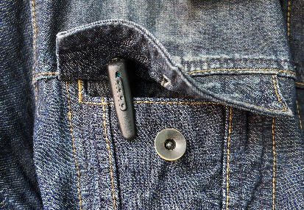

Device to capture the actions created by the disabled person and deliver to normal person using speakers or text.

**Architecture Diagram**

**Disabled to Normal People**

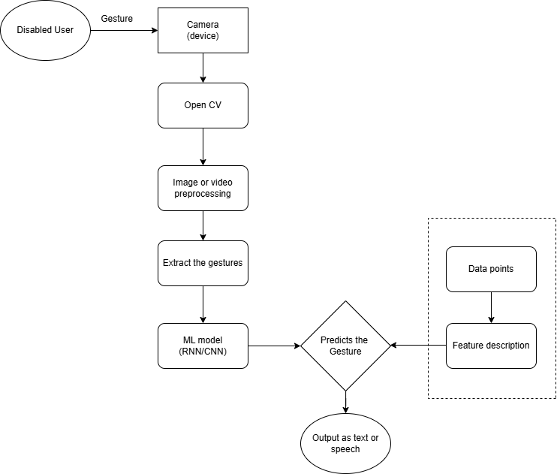

**Normal People to Disabled**

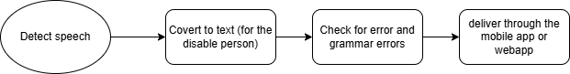

**Tech stacks**

**Software**

1. Image and video: Open CV
2. Scripting: Python
3. Web or Mobile App: React
4. Backend: MongoDB / SQL

**Hardware**

1. Camera
2. Microprocessor: Arduino
3. Actuators such as speakers.

**Flow Diagram**

**Disabled to Normal people**

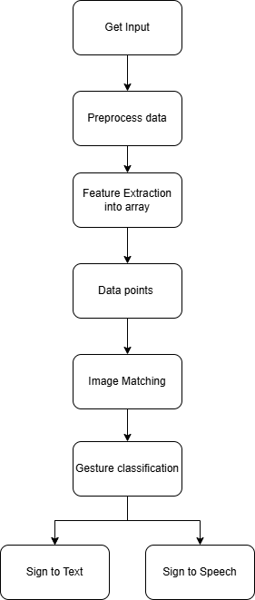

**Challenges:**

* Capturing complete hand gestures within the frame during video or image capture.
* Establishing adequate background lighting to ensure clear hand movements.
* Accurately delineating sign boundaries to differentiate between adjacent signs.
* Availability of the connection to the internet.

**Future Scope:**

* To develop this same solution that can work without any external networks (Wifi or internet).
* To improve the Encryption for the secure handling of the data.
* To reduce the size of the devices similar to the Hearing aid machine
* To enable the device to work in several modes such as (Night mode, High brightness and more).